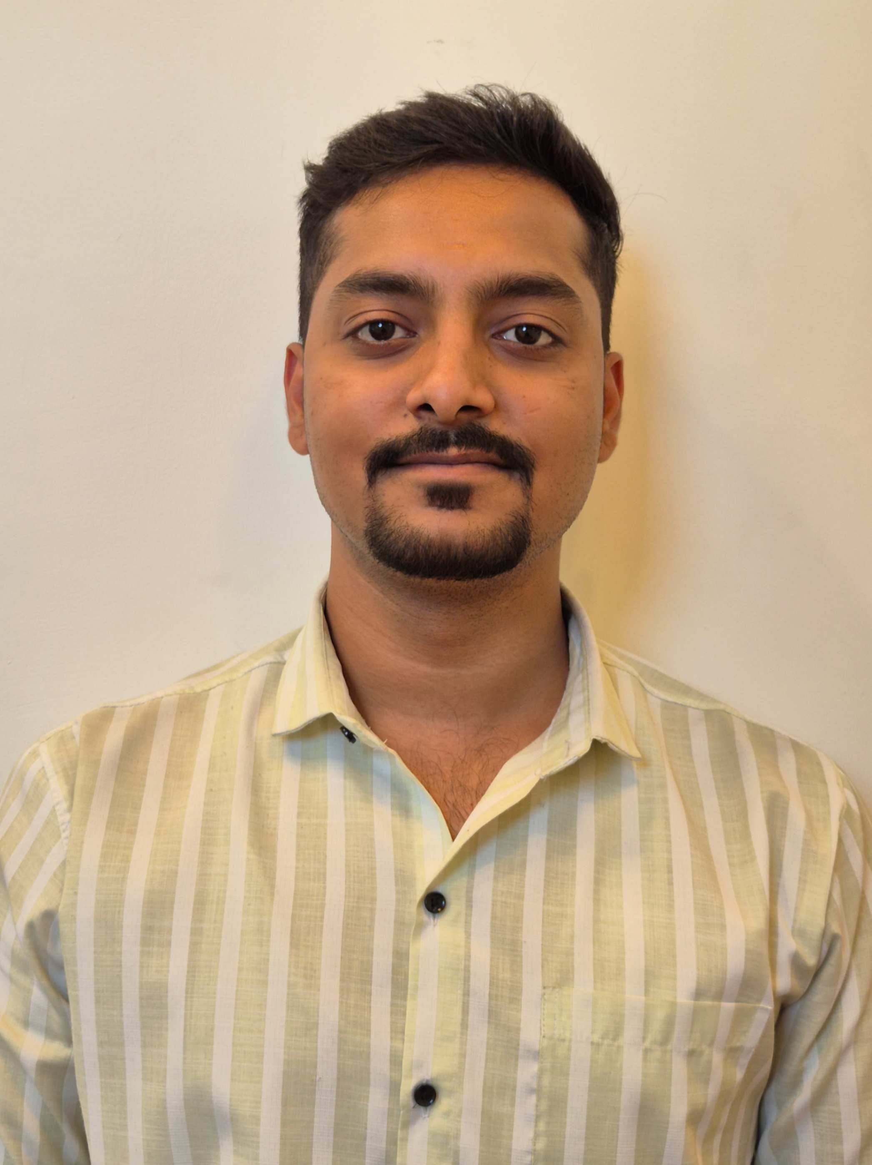

Personal Information Form

A. Applicant Details

Name (as in the Aadhar card) | Vivek |  |  | Anil |  |  |  |  | Choudhari
Current address  (If different than permanent address) | C-1402, Kohinoor Grandeur, Mukai Chowk,
Current address  (If different than permanent address) | Ravet-Kiwale
Current address  (If different than permanent address) | PCMC-412101
Current address  (If different than permanent address) | Tel. No.: Mobile No.: 9890293565
Permanent address | C-1402, Kohinoor Grandeur, Mukai Chowk,
Permanent address | Ravet-Kiwale
Permanent address | PCMC - 412101
Permanent address | Tel. No.: Mobile No.: 9890293565
Email ID | choudhari.vivek98@gmail.com
Citizenship (Passport Issuing country) | India
Country of Birth: | India
Date of birth (dd-mm-yyyy) | 03-12-1998
Marital status | [  ] Single [ ] Married [ ] Divorced
Gender | [ ] Male [ ] Female
Are you under any Service Agreement? | [ ] Yes [ ] No
Do you know anyone working with Persistent? | [ ] Yes [ ] No
Have you been interviewed at Persistent in the last 6 months? | [ ] Yes [ ] No Post applied for:  Date:
Languages known  (underline mother tongue) | Language |  | Read |  | Write |  | Speak |  |  | Proficiency if any
Languages known  (underline mother tongue) | English |  | Yes |  | Yes |  | Yes
Languages known  (underline mother tongue) | Marathi |  | Yes |  | Yes |  | Yes
Languages known  (underline mother tongue) | Hindi |  | Yes |  | Yes |  | Yes
Are you suffering/have you suffered from any critical illness | [ ] Yes [ ] No |  | If yes, give details
Have you been convicted / involved in any criminal litigation? | NO
Are you Willing to shift to related technologies as per business needs? | Yes [ ] | No [ ] |  |  |  | Need to think [ ] |  | Not Sure [ ]

Passport Details - Do you have a valid passport? [ ] Yes [ ] No

Details of Family Members (Parents / Siblings / Spouse / Children)

Sr. No | Name | Relationship | Age | Occupation
1 | Anil Vasant Choudhari | Father | 54 | Self Employed
2 | Dhanashri Anil Choudhari | Mother | 48 | Teacher
3 | Vidhaan Anil Choudhari | Sister | 22 | Student
4
5

B. Educational Details (From Highest Qualification)

Sr. No. | Educational Qualification | Year of passing | Percentage | University /Institute | State/ /Country
1 | B.Tech. | 2021 | 77.44 % | Vishwakarma Institute of Information Technology, Pune | Maharashtra, India
2 | 12th | 2017 | 69 % | Muktangan English Medium School & Jr. College | Maharashtra, India
3 | 10th | 2015 | 74 % | Bharti Vidyapeeth English Medium School | Maharashtra, India
4

Other Courses / Additional Qualification / Awards / Certifications

Sr. No. | Title of the course / program / qualification / award | Institute / University | Part Time/ Full Time | Duration & Year of passing
1 | Data Science Internship | ExcelR Solutions | Part Time | 6 Months & 2023
2 | Best Team Lead Award | Medimaze Solutions | - | 2024

Skills

Skills | Primary / Core Skills | Secondary Skills | Domain Expertise
Artificial Intelligence | Python | Image Processing | Deep Learning
Machine Learning | Deployment | SQL, NLP | Generative AI
Computer Vision | LLMs | Team Leadership | Healthcare AI

C. Employment History

Give details of the Employment (Latest first)

Sr. No. | Company Name and Tel.No. | Start  MM-YYYY | End  MM-YYYY | Last Position Held | Role / Nature of Duties | Software tools used | Last Salary drawn | Reasons for leaving
1 | Medimaze Solutions Pvt. Ltd., Pune | 05-2023 | - | Data Scientist | Leading a team for Data Science & AI, handling multiple projects A-Z | Python, Machine Learning, Deep Learning, Generative AI, SQL | June 2025 | Global Exposure & Career Growth
2 | Cognizant Technology Solutions, Pune | 07-2021 | 04-2023 | Programmer Analyst | Developing machine learning models to solve real-world business problems. Work with complex datasets, performing data cleaning, preprocessing, and analysis to uncover actionable insights. | Python, Machine Learning, Deep Learning, SQL | April 2023 | Skill enhancement, Leadership opportunities

D. Compensation

Please give details of your current salary. Please attach Photocopy of your last two months pay slip

Salary Head | Per Month (Rs.) | Per Annum (Rs.)
Basic + VDA | 30,304 | 3,63,644
HRA | 15,152 | 1,81,822
Transport Allowance | 1,600 | 19,200
Child Education Allowance | 200 | 2,400
Other Allowance | 28,504 | 3,42,044
Provident Fund @ 12% | 1,800 | 21,600
Professional Tax (PT) | 200 | 2,400
Employer PF Contribution @ 13% | 1,950 | 23,400
Gratuity @ 4.81% | 1,458 | 17,491
Fixed CTC (A + B) | 9,50,000
Annual CTC | 9,50,000
Monthly Net Payable | 73,759
Annual Net Payable | 8,85,109
Total | 9,50,000

Expected salary per month: Rs. 73759

Notice period required in current Job: 90 Days (Official NP)

Normal notice period: 15th Oct 2025 Earliest date you can join: 19th Sept 2025 (Negotiated to 60 Days)

Professional References who can be contacted (Give names of people other than your relatives) | Name | Contact details (Phone #,address) | Period from when known | Capacity in which he/she knows you
1 | Ashish Takawale | 7038091109 | 6 Years | 100%
2 | Jinendra Naik | 8888099084 | 2 Years | 100%

Specify your career achievements:

Comments by Applicant (if any):

DECLARATION

I, the undersigned, hereby declare that all the above information is valid & accurate to the best of my knowledge. I understand and fully agree that any information provided by me herein which is found to be erroneous or otherwise incorrect, which tend to mislead the Company will be sufficient cause for the Company to terminate my services from the Company at any time during my employment. I authorize the Company to carry out my reference / background check.

Date: 29/07/2025
(Signature of the Applicant)
Place: Pune, Maharashtra, India

